PHOTOGRAPHS TAKEN DURING JIV

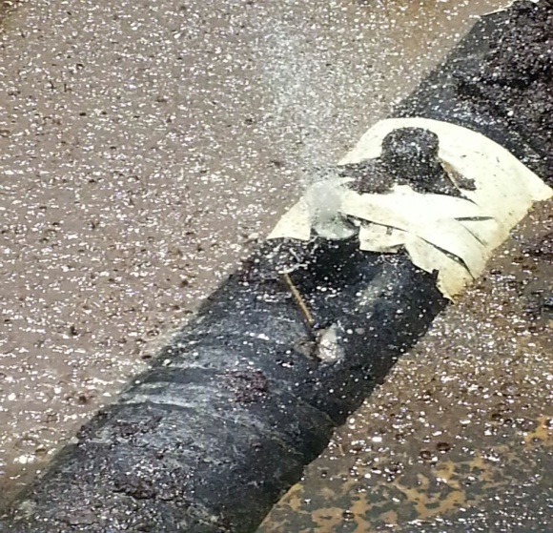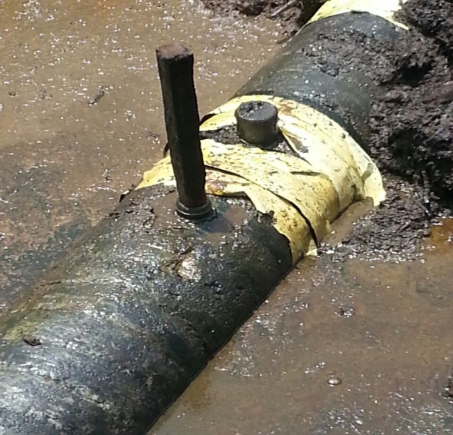
Fig A: picture taken after shutdown Fig B: picture taken after pecked

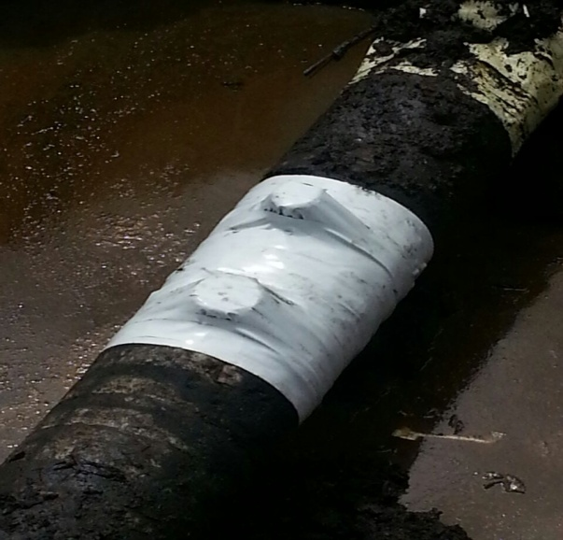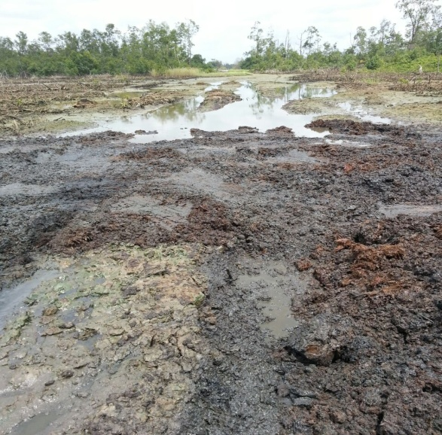
Fig C: picture taken after raped Fig D: picture taken after backfilled

